

**Name:** Fatima Malik

**Sap ID:** 40089

**Semester:** BSCS-6

**Course:** Computer Networks

**Lab 2**

**Task 1:**

**Write down the advantages & disadvantages of RJ45 connectors**

Advantages of RJ45 Connectors:

1. **Standardization**: RJ45 connectors are standardized for Ethernet networking, making them widely compatible with many devices and networks.
2. **High-Speed Data Transfer**: RJ45 connectors support high-speed data transfer rates, especially with modern Cat5e, Cat6, and Cat6a cables, which can handle Gigabit and even 10 Gigabit Ethernet.
3. **Ease of Use**: They are relatively easy to install and remove. The connectors snap into place securely, and most installations don't require specialized tools beyond a crimping tool.

### Disadvantages of RJ45 Connectors:

1. **Limited to Ethernet**: RJ45 connectors are specifically designed for Ethernet networks. They are not suitable for other types of data transmission like fiber optics without additional adapters or converters.
2. **Physical Size**: RJ45 connectors are relatively large compared to other types of connectors, which can be a disadvantage in tight spaces or high-density installations.
3. **Limited Cable Length**: For Ethernet connections using RJ45, the maximum recommended cable length is typically around 100 meters (328 feet) for reliable performance. Beyond this distance, signal degradation can occur.

**Task 2**:

**Briefly explain how data is transmitted in wireless medium**

In wireless data transmission, data is encoded into a digital signal and modulated onto a carrier wave, which is then transmitted via electromagnetic waves through the air. A receiving antenna captures these waves, demodulates them to retrieve the data, and decodes it back into its original form. This process allows devices to communicate without physical connections, utilizing modulation techniques for reliable data transfer.

**Task 3:**

**Briefly explain all type of network topologies**

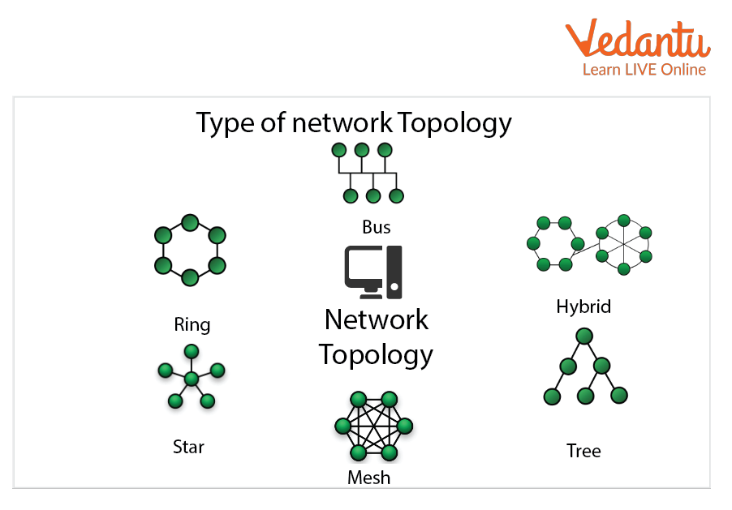

Types of Network Topologies:

1. **Bus Topology**: All devices connected to a single central cable. Data travels along this cable to reach all devices. It's simple but if the central cable fails, the whole network is affected.
   * **Example**: An old-school office LAN connecting all computers.
2. **Star Topology**: All devices connect to a central hub or switch. If one device fails, it doesn’t affect the others, but if the hub fails, the whole network is down.
   * **Example**: Most modern office networks with computers connected to a central network switch.
3. **Ring Topology**: Devices are connected in a circular. Data travels around the ring in one direction. If one device or connection fails, it can disrupt the entire network.
   * **Example**: Some older token ring networks used in large corporate environments.
4. **Mesh Topology**: Every device is connected to every other device. This provides high reliability with multiple paths for data but is complex and costly to set up.
   * **Example**: Large-scale networks like those used by Internet service providers or in large data centers.
5. **Tree Topology**: Combines star and bus topologies. Devices are grouped in star configurations connected to a central bus. It’s scalable but can be complex to manage.
   * **Example**: A university network where different departments (star-configured) connect to a central backbone (bus).
6. **Hybrid Topology**: Mixes different topologies, like star and bus. It combines the benefits of each but can be complicated to design and maintain.
   * **Example**: A large corporate network where different departments use star topologies connected to a central bus topology for overall network management.

Top of Form

Bottom of Form